Friends of the Davis Public Library
Board Meeting
December 10, 2020
Noon---via Zoom

Karen McCluskey, Jeff Lee, Kathy Coleman, Mabel Correa Reynolds, Mark Fink, Phil Coleman, Gary Godefroy, Holly Bishop, Hank Wyman, Linda Bernheim, Net Heberlein, Scott Love, Edith Vermeij, and Rory Osborne and were present as Rory called the meeting to order at 12:03.
I. October, 2020 Minutes
The minutes from October were approved by consensus.
II. Reports
A. Librarians
Mark sent out the following: “The Stay Home Order for our region goes into effect at 12:00 p.m. (midnight) on Friday, 12/11/20. According to the Order, residents are required to stay at home as much as possible to reduce the spread of COVID-19 and to prevent overwhelming regional ICU capacity. To do our part to reduce COVID-19 transmission in our communities, Yolo County Library curbside service and in-person computer appointments will be suspended starting Friday. Services will be suspended for a minimum of three weeks and resume once it is safe to do so, based on guidance from Yolo County's Public Health Officer.”
Phone service and Books by Mail will continue.
B. President
Rory notes that we have cancelled our next two sales due to the closure. Then comes Christmas and New Years. We discussed also staying closed during January. It is cold and we would then be building up inventory for the upcoming warmer months.
C. Treasurer
Kathy recently sent out her excellent reports. We have grossed over $14,600 in sales and over $5,000 in memberships at our little one-day sales.
D. Donations/Sorting—Nancy
Donations keep coming in.
E. Membership—Jeff
Jeff notes that we have 517 active members. 222 members used their cards during the one day sales.
F. Special Events/Projects—Hank
Hank has made little progress on most things, but is developing a tee shirt for Logos.
G. Library Advisory Board—Holly
Little is happening with this.
H. Book Mending—Net
Menders continue to meet weekly via Zoom and are very anxious to resume mending. Karen and Jeannette have been doing a bit of work with Phil for special books for Logos and with private mends.
- Website—Linda
We are coming up on renewal dates for two URLs. Other than that, she is just keeping up with updates to info on the site.
- Reading Garden—Edith
She has tried to contact her volunteers, but is getting a bit worried with low response. She will keep trying.
- Logos—Phil
Logos is doing wonderfully. This last month has seen great sales, even with reduced hours. Phil notes that they now have a bunch of much younger cashiers and even younger customers.
In December, the heating and air system was cleaned and Phil is keeping up with robust, new filters.

III. Old Business/Action Items from June
- Progress with Publicity and Sale of Valuable Books
Phil sent us all a very nice document outlining how Logos is marketing valuable books. It is attached at the end of the minutes.
- Update on Donor Wall
This is on hold.
V. New Business
A. Linda Olsen
Rory asked to add Linda to the Board several months ago, but she has not really been involved for various reasons. We decided to remove her from the Board. (Rory moved, Gary seconded and it was done).
- Reopening Plans for the Library/HVAC air filtration
The system is not capable of handling Hepa filters right now. Physical Plant is replacing the current filters more often.
- Avid Reader
Rory ran into one of the owners recently and suggests that we put an ad for Avid Reader on our website. We want them to thrive.
- Hypothetical Sale Dates and Board Meeting Dates for 2021
Friday Dates for Three Day Sales—
February 5
April 2
June 4
August 6
October 1
December 3
While these are unlikely to happen as usual, they do help with planning for the member benefit cycles. Bookmarks could note “Library Facilities Permitting” and that Friday One Day Sales are probable.
Meeting Dates for 2021
Februrary 11
April 8
June 10
August 12
October 14
December 9
The Annual Meeting will remain open at this time.

Action Items for February 11 meeting—
Donor Wall
Logos Tee Shirts

The meeting adjourned at 1:20.

The next regular Board Meeting will be Thursday, February 11, 2021 at noon.

Check out the web site at www.davislibraryfriends.org.
It really is beautiful and informative and includes a lot of information about Logos.

Submitted by Karen McCluskey

________________________________________________________________________________________
Friends’ purpose: To assist the Davis Public Library in efforts to raise funds, plan for expansion of physical facilities, develop the library’s book collection, encourage reading programs for children, and to promote the library as a cultural center for the city of Davis

Elected and Appointed Board Members and Library Staff
2020-2021

Phil Coleman, Logos Books
Rory Osborne, President Kathy Coleman, Treasure
2402 Amapola Drive treasurer@davislibraryfriends.org (Kathy)
Davis 95616 716 Kestrel Place
750-3825 Home cell 530-902-1363 (Kathy)
219-9698 Cell home-756-4885
roryosborne@gmail.com cell 530-902-3009 (Phil)
logos@davislibraryfrineds.org (Phil)

Karen McCluskey. Secretary
268 Cottage Circle
Gary Godefroy, Vice President for Book Sales Davis, 95616
3746 Modoc Place , Davis 95818 530-400-5774 Cell
759-9877 Home ksmccluskey@ucdavis.edu
530-400-3610 Cell
ggodefroy45@gmail.com

Mark Fink, County Librarian
mark.fink@yolocounty.org Nancy Holland, Book Donations
1608 Monarch Lane
Jeff Lee, Vice President Membership NHoll24287@aol.com
jeff@davislibraryfriends.org 219-5656--cell
Scott Love, Library Regional Manager
Holly Bishop, Library Advisory Board 530-757-5595
holly@hollytime.com 530-312-6463 Cell
scott.love@yolocounty.org
Linda Bernheim, Web Site
linda@davislibraryfriends.org Edith Vermeij, Reading Garden
530-756-9210 evermeij@gmail/com
756-8822
Mabel Correa Reynolds, Book Sale Postcards
mmmcr4@gmail.com
Hank Wyman, Special Events
henrycwyman@mac.com

Net Heberlein, Book Menders
1008 Dolcini Lane Davis, CA 95618
530-758-1359-home
530-304-7879-cell
Horseev2@yahoo.com

web site: www.davislibraryfriends.org
email: davisfriendsofthelibrary@gmail.com
Friends Facebook Page: https://www.facebook.com/pages/Friends-of-the-Davis-CA-Library

6/4/20

MARKETING OUR MORE VALUABLE

DONATED BOOKS

By: Phil Coleman

Is Logos/FOL now using the Internet to sell its books?

Yes, books that we recently classified as “Valuable Books.” The term follows the book industry norm for such items. Valuable books are not the same as our existing “Vintage” category. Vintage books are generally more valuable because of their date of publication. Valuable books have several criteria. Nothing changes with our Vintage Category.

These “valuable” books, how do we sell them using the Internet?

An account has been opened in the name of Logos Books using the services of the nation’s largest independent bookseller and was recommended to us by a professional book buyer:
biblio.com/bookstore/logos-books-davis
We have about 50 books listed already, and keep adding more. Logos has already made some sales. The listing is also good advertising for the store, which includes a full description and a current photo of the interior.

What price-range are we talking about, is it just books that are worth hundreds of dollars?

No, in fact our book listings are generally in the $35 - $50 range. Since the buyer has to pay minimum $6 in shipping, we don’t list many books under $20. We do have a listing of $600, and several others in the hundreds of dollars.

How do you determine the asking price?

The first step is look at all competing listings of comparable books. Then we take the lowest value listing and sell our books for less than that. Professional booksellers have cost issues that Logos does not have.

Are there any fees involved and how is the money we receive from valuable book sales given to us?

Biblio.com is a business, and charges a modest service fee to successful sellers, the lowest in the industry. In exchange, we are able to reach a world-wide audience of several millions of book buyers. Biblio.com makes direct deposits of our sales to the Friends bank account and message the Treasurer. We have a full accounting for every book sold, just like we do with store sales.

What makes a Valuable Book, Valuable?

The biggies are these in no rank order, Condition, Dust Cover, Signed by Author, First or Limited Edition, Age. One of these is great, more than one is really great!
A signed, First Edition, in fine condition of Margaret Mitchell’s, “Gone with the Wind,” is listed at $16,600. If you find a second Mitchell, don’t put it in the box or stick it in the Dollar Cart. Call me, stat.

Well then, I happen have some valuable donated books in my inventory and wasn’t sure what to do with time, can I put them someplace for evaluation and possible posting on this list?

Yes, of course. We’ll have a box (see photo) on the large table in the back room. Put any such books in there and it will be researched and evaluated for possible sale, then give you feedback. If we sell “your” book you’ll be appropriately recognized for the discovery and helping add to the supplemental funding of the local library.

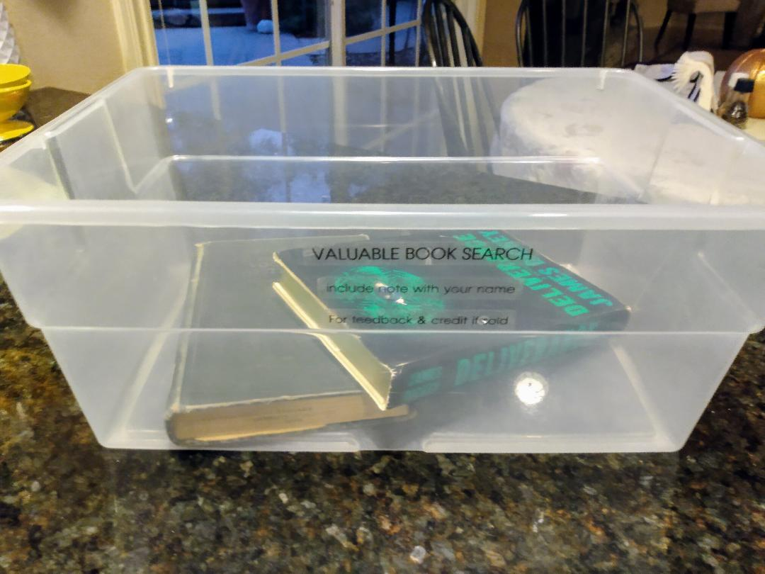

Is it just Logos volunteers who are involved with this way of marketing?

For years, our colleagues, the FOL volunteers at the Library, have been identifying and storing valuable books for later display at the scheduled book sales or long-term storage. The success rate for these books at the book sales has been limited. The Library volunteers are also participating in this form of marketing and given us several marketable books.

What about some valuable books that are really dirty or damaged? Can we fix them up a bit to make them more salable?

Usually, altering a valuable book diminishes its value. We will contact one of the “Menders” at FOL. Menders know everything there is to know about old, damaged and fragile books. We can arrange for a damaged book for inspection and decide on cleaning and mending.
(Nov.-20)

